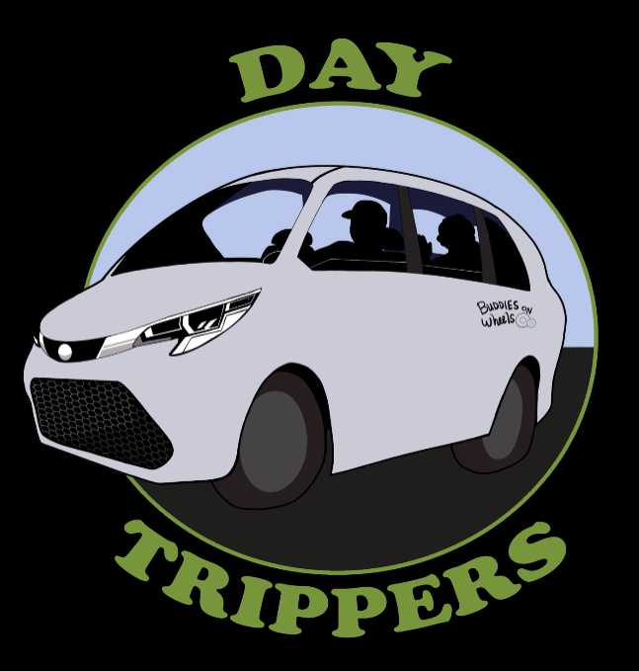

PRIVATE PAY

1/2 HR. = $15+$5/GAS = $20X2 = $40 X 5 DAYS/WK = $200/WEEK

(*SUMMER SPECIAL*) BUDDIES PAY ONLY $175 FOR THE FIRST WEEK ONLY!
SPECIALS APPLY TO FULL WEEK RIDERS ONLY! (MONDAY- FRIDAY) BEGINNING OF SECOND WEEK BUDDIES PAY FULL FEE OF $200/WK.

1 DAY = $55

2 DAYS = $110

3 DAYS = $165

4 DAYS = $220

5 DAYS - SAVE $20 FOR A FULL WEEK MONDAY- FRIDAY

NOTE: A DAYTRIPPERS T-SHIRT WILL BE INCLUDED ONLY FOR RIDERS THAT RIDE 3 OR MORE DAYS/WEEK

NOTE* DAYTRIPPERS WILL PROVIDE A SNACK, BOTTLED WATER, MASK (IF NEEDED) HAND SANITIZER, AND CHOICE OF STRESS-FREE TOY FOR ALL BUDDIES REGARDLESS OF # OF DAYS RIDING.

